# **Contract Monthly Claim System Prototype**

## **Introduction**

This report provides an overview of the design and creation of a prototype for the Contract Monthly Claim System. The purpose of this system is to enhance the efficiency of claim submissions by lecturers and streamline the verification and approval process by program coordinators and academic managers. This report covers the choices made in design, the structure of the database, the layout of the GUI, the project plan, and the version control approach used for the prototype.

## **Design Choices**

### **Database Structure**

The database is structured using a relational model to effectively handle organized data. It comprises the following tables:

* **Users**: Contains details about users, including usernames, passwords, and roles (lecturers, coordinators, and managers).
* **Claims**: Records claim submissions with fields such as ClaimID, UserID, Amount, Status, and SubmissionDate.
* **Documents**: Handles supporting documents for each claim, featuring attributes like DocumentID, ClaimID, FilePath, and UploadDate.
* **Approvals**: Records approvals by coordinators or managers, with fields such as ApprovalID, ClaimID, ApproverID, and ApprovalDate.

### **GUI Layout**

The graphical user interface is crafted using MVC .NET core to ensure it is intuitive and user-friendly. The layout includes:

* **Login Page**: Provides secure access for users through fields for username and password.
* **Claim Submission Form**: Enables lecturers to file claims with inputs for amount, description, and document uploads.
* **Approval Page**: Allows coordinators and managers to view and approve claims.
* **Status Tracking Page**: Shows the status of claims, giving users updates.

## **Assumptions and Constraints**

It is assumed that each user has a unique username and that only lecturers can submit claims. Supporting documents need to be in PDF format, with a maximum file size to facilitate easy uploads. The system includes security features to protect user data and maintain role-based access control.

## **UML Class Diagram**

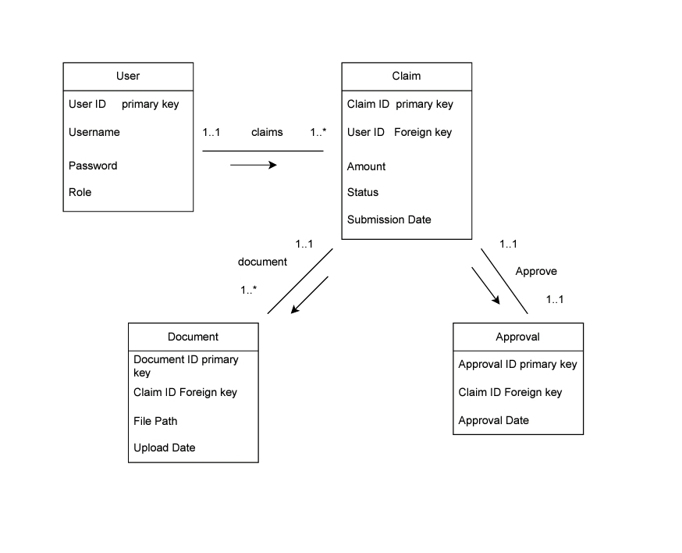

The UML class diagram illustrates the data requirements and the relationships among entities:

* **User**: UserID, Username, Password, Role
* **Claim**: ClaimID, UserID, Amount, Status, SubmissionDate
* **Document**: DocumentID, ClaimID, FilePath, UploadDate
* **Approval**: ApprovalID, ClaimID, ApproverID, ApprovalDate

The relationships are: User 1 to * Claim, Claim 1 to * Document, and Claim 1 to 1 Approval.

## **Project Plan**

The project is planned over a five-week timeline:

1. **Week 1**: Collect requirements and design the initial concept.
2. **Week 2**: Develop the database schema and create the UML diagram.
3. **Week 3**: Design the GUI wireframe.
4. **Week 4**: Integrate the database schema with the GUI prototype.
5. **Week 5**: Conduct reviews, make adjustments, and finalize.

## **Version Control**

The project uses GitHub for version control, with several well-documented commits:

1. **Initial Commit**: Established the basic project structure.
2. **Database Design Commit**: Added the UML diagram and database schema.
3. **GUI Design Commit**: Developed the initial GUI layout.
4. **Integration Commit**: Connected the GUI with the database schema.
5. **Final Review Commit**: Updated documentation and implemented final changes.

### **Conclusion**

The prototype for the Contract Monthly Claim System offers a solid foundation for managing claim submissions, approvals, and status tracking. Although this version is a non-functional prototype, it establishes a basis for future development and deployment. This report provides insight into the design decisions and their rationale, ensuring a robust and scalable system design.

# Refences

Dofactory, 2024. Prototype design, 17 March 2024. [Online]. Available At <https://www.docfactory.com> [Accessed on 25 August 2024].

Learnmicrosoft, 2023. Use.net, 26 September 2023.[Online]. Available At <https://lLearn.microsoft.com> [ Accessed on 22 August 2024].

Leanmicrosoft, 2023. C# guidance, 24 September 2023. [Online]. Available At <https://learn.microsoft.com> [ Accessed on 22 August 2024].

W3Schools, 2024. C# tutorial, 12 January 2024. [Online]. Available At <https://W3Schools.com> [Accessed on 27 August 2024].